YOUR PAPER'S TITLE STARTS HERE: PLEASE
(Use Arial 14 Bold)
B. Barish ¹, J. Kudla ² and T. Pepely³ (use Arial 12)
¹ Full Address of First Author, Single Line Spacing, Single Line Spacing, Single Line Spacing
Single Line Spacing, Country (use Arial 10)
² Full Address of Second Author, Single Line Spacing, Single Line Spacing, Single Line Spacing
Single Line Spacing, Country
³ Full Address of Third Author, Single Line Spacing, Single Line Spacing, Single Line Spacing
Single Line Spacing, Country

Keywords: List the keywords covered in your paper. These keywords will also be used by the publisher to produce a keyword index. (use Arial 10)

Abstract. For abstract use size and type Arial 10 and for the main text body Arial 8. The best is to read these instructions and follow the outline of this text. The text area for your manuscript must be in A4 format please use the template. Do not place any text outside template area, please follow the instructions exactly..

Introduction
All manuscripts must be in English. Please keep a second copy of your manuscript in your office (just in case anything gets lost in the mail). When receiving the manuscript, we assume that the corresponding authors grant us the copyright to use the manuscript for the book or journal in question. Should authors use tables or figures from other Publications, they must ask the corresponding publishers to grant them the right to publish this material in their paper.
All manuscripts must be in English. When receiving the manuscript, we assume that the corresponding authors grant us the copyright to use the manuscript for the book or journal in question. Should authors use tables or figures from other Publications, they must ask the corresponding publishers to grant them the right to publish this material in their paper.
Use italic for emphasizing a word or phrase. Do not use boldface typing or capital letters except for section headings (cf. remarks on section headings, below).

Section Headings
The section headings are in boldface capital and lowercase letters. Second level headings are typed as part of the succeeding paragraph (like the subsection heading of this paragraph).

Second Level Headings
Second level headings are typed as part of the succeeding paragraph (like the subsection heading of this paragraph). Second level headings are typed as part of the succeeding paragraph (like the subsection heading of the previous paragraph).

Page Numbers
Please set page number as shown in the template.

Footnotes
Footnotes should be single spaced and separated from the text. Ideally, footnotes appear on the page of their reference, and are placed at the foot of the text, separated from the text by a horizontal line.

Tables
Tables (refer with: Table 1, Table 2, ...) should be presented as part of the text, but in such a way as to avoid confusion with the text. A descriptive title should be placed above each table. The caption should be self-contained and placed below or beside the table. Units in tables should be given in square brackets [meV] and used unit standards should be specified in text.

Table 1. Text of table above the table

Nr. Piec. | Name | Material | Kg | Pos.
10 | Back of chair | Ø5x490 | 0.076 | 04
1 | Leg holder | Ø6x1062 | 0.236 | 03
1 | Front legs | Ø20x1.2 x 1948 | 1.112 | 02
1 | Back legs | Ø20x1.2 x 2250 | 1.380 | 01
Figures
Figures (refer with: Fig. 1, Fig. 2, ...) also should be presented as part of the text, leaving enough space so that the caption will not be confused with the text. The caption should be self-contained and placed below or beside the figure as show in Fig. 1. Only very good photocopies are acceptable, text must be readable with minimum text height size of 1 mm.

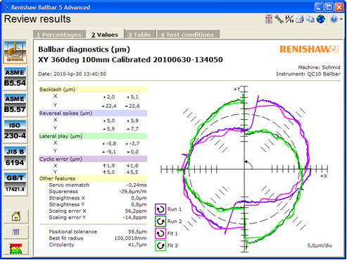

Fig. 1 Text of figure
Equations
Equations (refer with: Eq. (1), Eq. (2), ...) should be indented 6.35 mm (18 pt or 0.25"). There should be one line of space above the equation and one line of space below it before the text continues. The equations have to be numbered sequentially, and the number put in parentheses at the right-hand edge of the text. Equations should be punctuated as if they were an ordinary part of the text. Punctuation appears after the equation but before the equation number. For example, we may have an equation

F = c/2 + a², (1)

where: F is the first variable, c is the second variable and a is the third variable.

Conclusion
Please provide your phone number and e-mail address for rapid communication with us (will not be published). Please send your final soft copy through an e-mail. If you follow the foregoing, your paper will conform to the requirements and facilitate a problem-free publication process.

Acknowledgment

Please put any acknowledgments between conclusion and references

References

References are cited in the text just by square brackets [1]. Two or more references at a time may be put in one set of brackets [3, 4]. The references are to be numbered in the order in which they are cited in the text and are to be listed at the end of the contribution under a heading References, see our example below.

[1] Initial(s) Surname, Initial(s) Surname and Initial(s) Surname: Title of paper, Title of journal, Vol. volume number (year), No. number, pp. page number - page number.
[2] T. Pepely, B. Barish: Modelling and Simulation of Nonhomogenous Yielding, Journal of Materials Processing Technology, Volume 186 (2007), Issues 1-3, p. 111-119.
[3] Initial(s) Surname, Initial(s) Surname and Initial(s) Surname: Title of paper, Proc of conference, Organizer/venue of conference, Vol. volume number (year), pp. page number - page number.
[4] M. Gom, T. Herc: Analysis of Digitizing and Traditional Measuring System, Proc of 4th INTECH International Conference on Innovative Technology in Design, Manufacturing and Production, Vol. 4 (2009), pp. 49-54.
[6] Initial(s) Surname, Initial(s) Surname and Initial(s) Surname: Title of book (Publisher, Place of publication, year).
[7] G. T. Smith: Industrial Metrology-Surface and Roundness, (Springer, London, 2002).

Length of paper
Full Length Paper: max four pages A4. Be careful because more pages will not be acceptable. To accept the contribution it is necessary to observe all the above conditions and send paper in DOCX format.

